

|  |  |  |  |  |  |  |  |  |
| --- | --- | --- | --- | --- | --- | --- | --- | --- |
|  | | | | | | | | |
|  | | EXPLORATORY DATA ANALYSIS | | | | |  | |
|  |  | | | | | | |  |
|  | | | |  |  | | | |
|  | | | | PURIGILLA VENKATA RAHUL INTERNSHIP MAJOR PROJECT TEACHNOOK |  | | | |
|  | | | | ARTIFICIAL INTELLIGENCEAUGUST BATCH |  | | | |
|  | | |  | | |  | | |



|  |  |  |  |  |  |  |  |  |
| --- | --- | --- | --- | --- | --- | --- | --- | --- |
|  |  | | |  |  | | |  |
|  | PROBLEM STATEMENT | | | | | | |  |
|  |  | | |  |  | | |  |
|  |  | |  | | |  | |  |
|  |  |  | Take any Dataset of your choice ,perform EDA(Exploratory Data Analysis) and apply a suitable Classifier ,Regressor or Clusterer and calculate the accuracy of the model | | |  |  |  |
|  | | | | |
|  |  |  |  |
|  |  |



|  |  |  |  |  |  |  |  |  |
| --- | --- | --- | --- | --- | --- | --- | --- | --- |
|  | |  |  | |  |  | | |
|  | | THE PROCESS AND THE DESCRIPTION | | | |  | | |
|  | |  |  | |  |  | | |
|  | EXPLORATORY DATA ANALYSIS The exploratory data analysis is used to summarize , visualize and project the data. This process is useful to calculate the statistics of the data and depict the data visually. | | | | | | |  |
|  | MODULES AND THE SOFTWARE USED | | | THE MODULES IMPORTED ARE | | |  |  |
|  | This project of exploratory data is completely built using python. | | | Pandas, sklearn, Ipython , statesmodel etc all these modules collectively work on generating the data analysis | | |  |  |

##### SOURCE CODE

import pandas as pd

import numpy as np

from sklearn.model_selection import train_test_split

from sklearn.linear_model import LogisticRegression

from sklearn import metrics

import matplotlib.pyplot as plt

url = "https://raw.githubusercontent.com/Statology/Python-Guides/main/default.csv"

data=pd.read_csv(url)

data[0:6]

len(data.index)

X = data[['student', 'balance','income']]

y = data['default']

X_train,X_test,y_train,y_test = train_test_split(X,y,test_size=0.3,random_state=0)

log_regression = LogisticRegression()

log_regression.fit(X_train,y_train)

y_pred = log_regression.predict(X_test)

cnf_matrix = metrics.confusion_matrix(y_test, y_pred)

cnf_matrix

print("The accuracy of the given model is : ",metrics.accuracy_score(y_test, y_pred))

y_pred_proba = log_regression.predict_proba(X_test)[::,1]

fpr, tpr, _ = metrics.roc_curve(y_test,  y_pred_proba)

auc = metrics.roc_auc_score(y_test, y_pred_proba)

plt.plot(fpr,tpr,label="AUC="+str(auc))

plt.legend(loc=4)

plt.show()

The data set used here contains the data about the income of various students from many countries the output shows the accuracy of the data set and also manifests the logistic regression graph for that data set.

##### OUTPUT

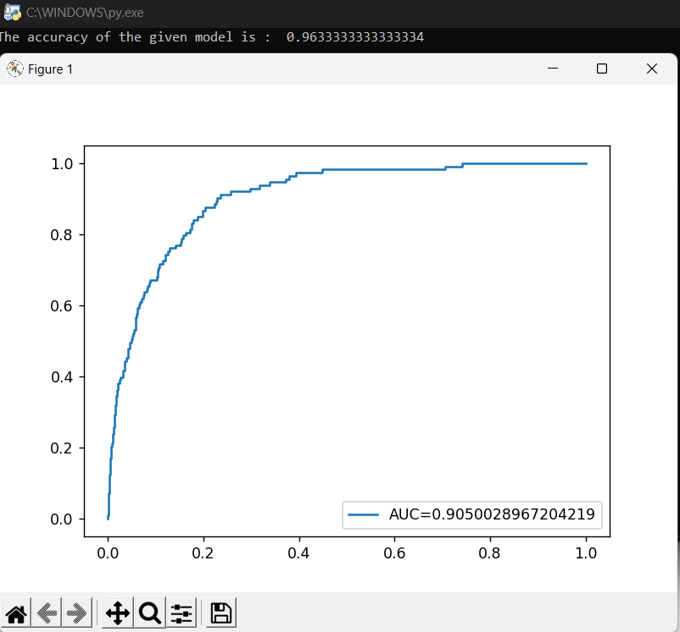

##### GITHUB LINK

https://github.com/rahulmoc2002/Majotproject1

import pandas as pd

import numpy as np

from sklearn.model_selection import train_test_split

from sklearn.linear_model import LogisticRegression

from sklearn import metrics

import matplotlib.pyplot as plt

url = "https://raw.githubusercontent.com/Statology/Python-Guides/main/default.csv"

data=pd.read_csv(url)

data[0:6]

len(data.index)

X = data[['student', 'balance','income']]

y = data['default']

X_train,X_test,y_train,y_test = train_test_split(X,y,test_size=0.3,random_state=0)

log_regression = LogisticRegression()

log_regression.fit(X_train,y_train)

y_pred = log_regression.predict(X_test)

cnf_matrix = metrics.confusion_matrix(y_test, y_pred)

cnf_matrix

print("The accuracy of the given model is : ",metrics.accuracy_score(y_test, y_pred))

y_pred_proba = log_regression.predict_proba(X_test)[::,1]

fpr, tpr, _ = metrics.roc_curve(y_test,  y_pred_proba)

auc = metrics.roc_auc_score(y_test, y_pred_proba)

plt.plot(fpr,tpr,label="AUC="+str(auc))

plt.legend(loc=4)

plt.show()